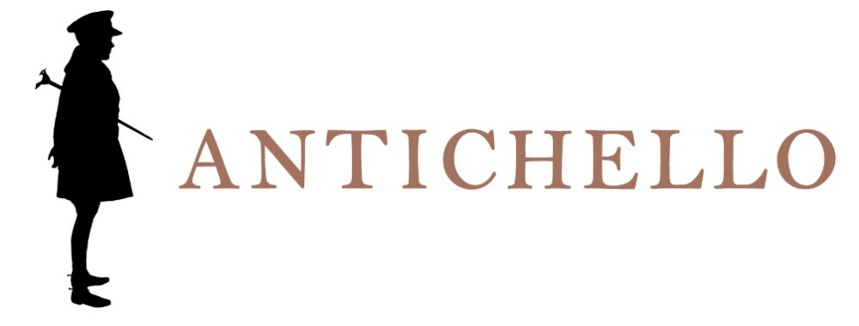

SOAVE
DENOMINAZIONE DI ORIGINE CONTROLLATA

Production area
Soave area.

Grape varieties
Garganega e Trebbiano di Soave.

Vinification
Soft pressing and fermentation at a controlled temperature.

Refinement
In stainless steel vats and about 3 months in bottle.

WINE ANALYSIS
Alcohol: 12% by Vol.
Total acidity: about 5.50 g/l

Sensory impressions
Straw yellow colour.
Characteristic flowery and spicy bouquet.
Dry, velvety and pleasantly sapid taste.

Serving information
8° to 10° C.

Dining accompaniment
Hors d’oeuvre and first courses.

Longevity
To drink preferably young.

