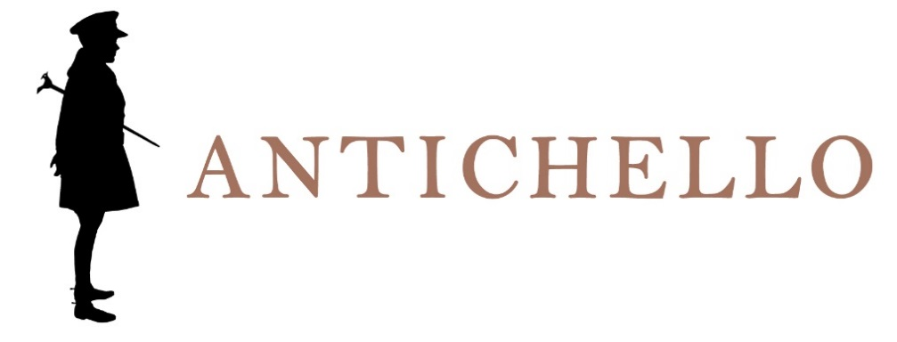

CHIARETTO DI BARDOLINO
DENOMINAZIONE DI ORIGINE CONTROLLATA

Production area
Bardolino, to the east of Lake Garda.

Grape varieties
Corvina, Rondinella and Molinara.

Vinification
Soft pressing of the grapes with short maceration of the skins.

Wine analysis
Alcohol: 12% by Vol.
Total acidity: about 5.5-6 g/l.

Refinement
In stainless steel vats and about 3 months in bottle.

Sensory impressions
Pinkish colour with purple nuances.
Delicate bouquets with fruity and floral hints.
Dry taste, fresh and slightly sapid.

Serving information
14° to 15° C.

Dining accompaniment
First courses, even with fish, and white meat.

Longevity
To drink preferably young.

